1. Java Date and Time :
#CODE:
import java.util.*;

public class Solution {

public static String findDay(int month, int day, int year) {

Calendar cal = Calendar.getInstance();

cal.set(year, month - 1, day);

String[] days = {
"SUNDAY",
"MONDAY",
"TUESDAY",
"WEDNESDAY",
"THURSDAY",
"FRIDAY",
"SATURDAY"
};

return days[cal.get(Calendar.DAY_OF_WEEK) - 1];
}

public static void main(String[] args) {

Scanner sc = new Scanner(System.in);

int month = sc.nextInt();
int day = sc.nextInt();
int year = sc.nextInt();

System.out.println(findDay(month, day, year));

sc.close();
}
}

OUTPUT:
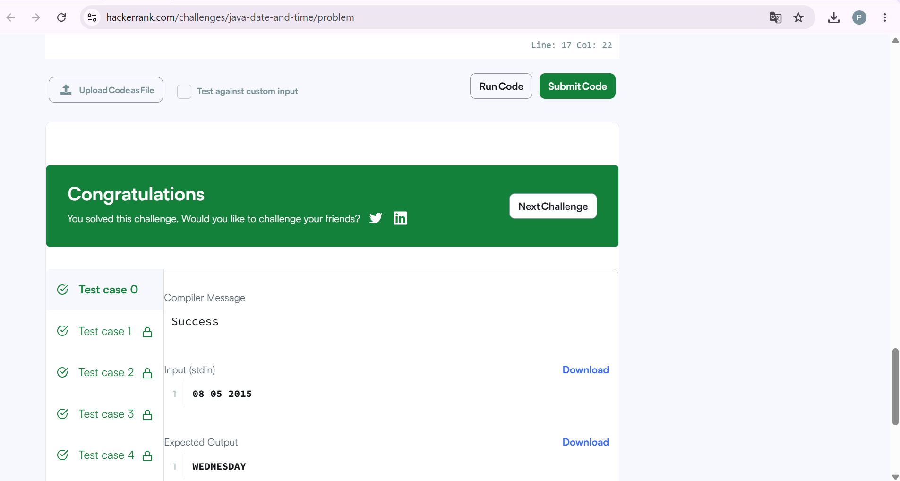

2. Number of Days Between Two Dates :
#CODE:
import java.time.LocalDate;
import java.time.temporal.ChronoUnit;

class Solution {
public int daysBetweenDates(String date1, String date2) {

LocalDate d1 = LocalDate.parse(date1);
LocalDate d2 = LocalDate.parse(date2);

return (int) Math.abs(ChronoUnit.DAYS.between(d1, d2));
}
}

OUTPUT:
